Teens Summer Reading Program 2021:
Tails & Tales
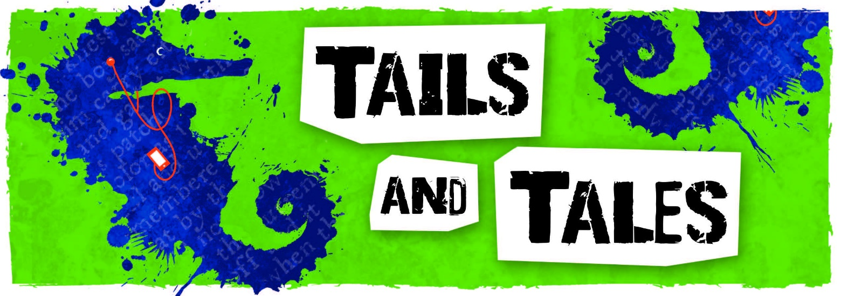
- Summer reading kickoff party June 12 11-1 join us for games and lunch! AT EDCO PARK
- Outdoor Family Movie Night: Join us June 18 at 9:20 p.m. for an outdoor showing of Disney’s live action Aladdin. Please bring your own chair to set up in front of the library. Spots are first come, first serve. There will be movie snacks and drinks for purchase and a raffle.
- Bring home some family fun with a Grab and Go Steam Kit (Science, Technology, Engineering, Art, and Math)
          - Available June 28th and July 19th
- Teen Fantasy Book Club June 22nd and July 13 at the library from 11-12 snacks will be provided. We are reading Inkheart by Cornelia Funke.
- Pick up your own graphic novel kits at the library and return them by June 30th to win extra tickets towards the prize baskets.
- Retro Game Day July 27th at the library from 11-1, snacks provided.
- Pick up your own Break-in bags at the library. It is a mini escape room in bag form, only instead of trying to break out; you are trying to break in. Each bag is closed with a 3-digit numeric lock and comes with a sheet containing three puzzles; the answer to each puzzle corresponds to a number on the lock. In order to open the bag and get the goodies inside, you have to enter the correct 3 digits onto the lock. Break-in kits due July 28.
- Get outdoors and complete an activity or program at Moraine State Park throughout the summer to win extra tickets. Take a picture completing your favorite outdoor activity!
- End of Summer Reading Party August 2nd from 11:30-1:30 at Edco Park!

Register for this year’s summer reading program at www.evanscitylibrary.org

